School Of Mechanical & Manufacturing Engineering, NUST

Department of Mechanical Engineering

**Lab Manual # 05**

.

**Home Tasks:**

**Task 1:**

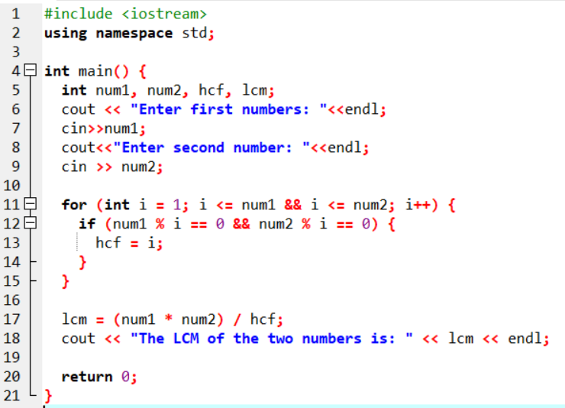

**Output:**

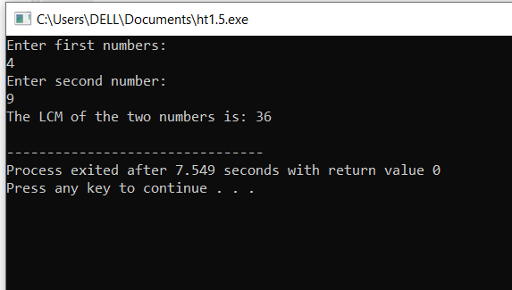

**Task 2:**

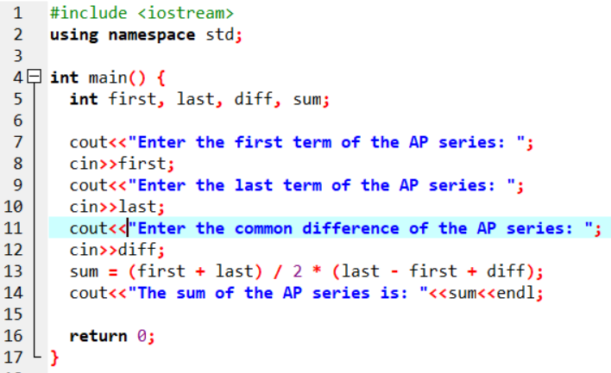

**Output:**

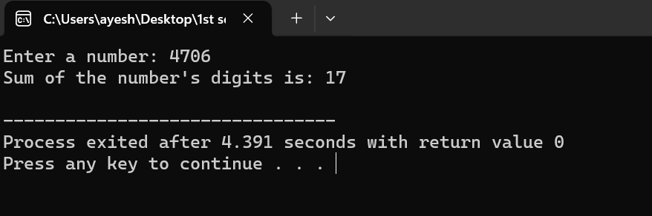

**Task 3:**

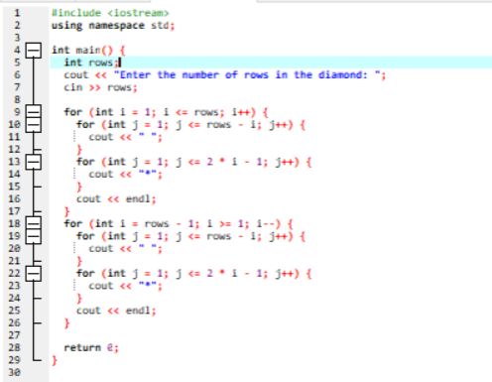

**Output:**

